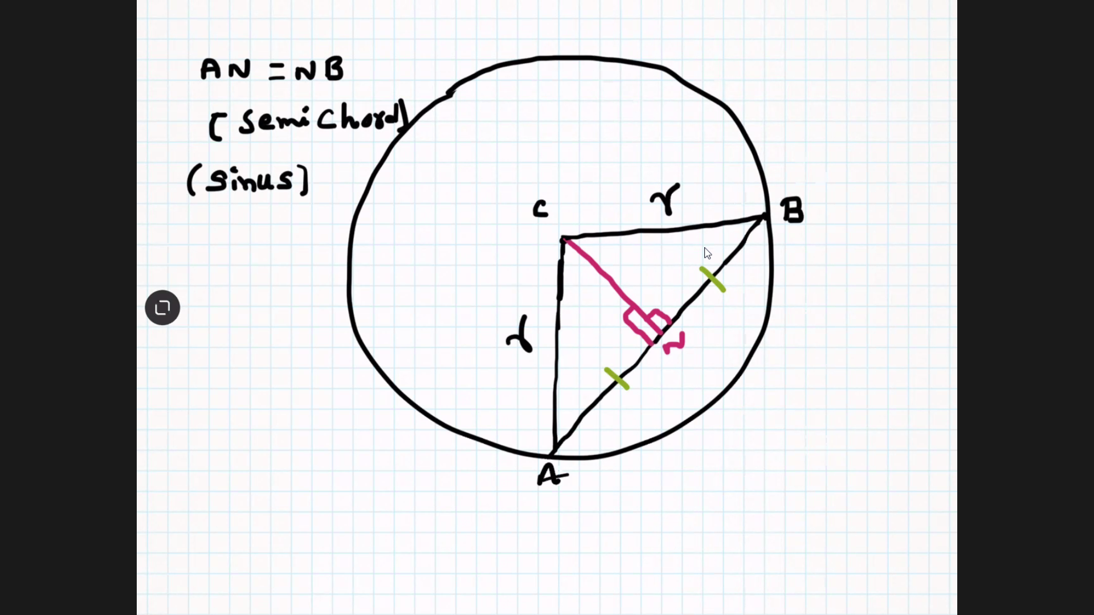

RHS --- Right angle, hypotenuse, side (Sides opposite to right angles {hypotenuse] are equal, common side)

SSS --- side, side , side

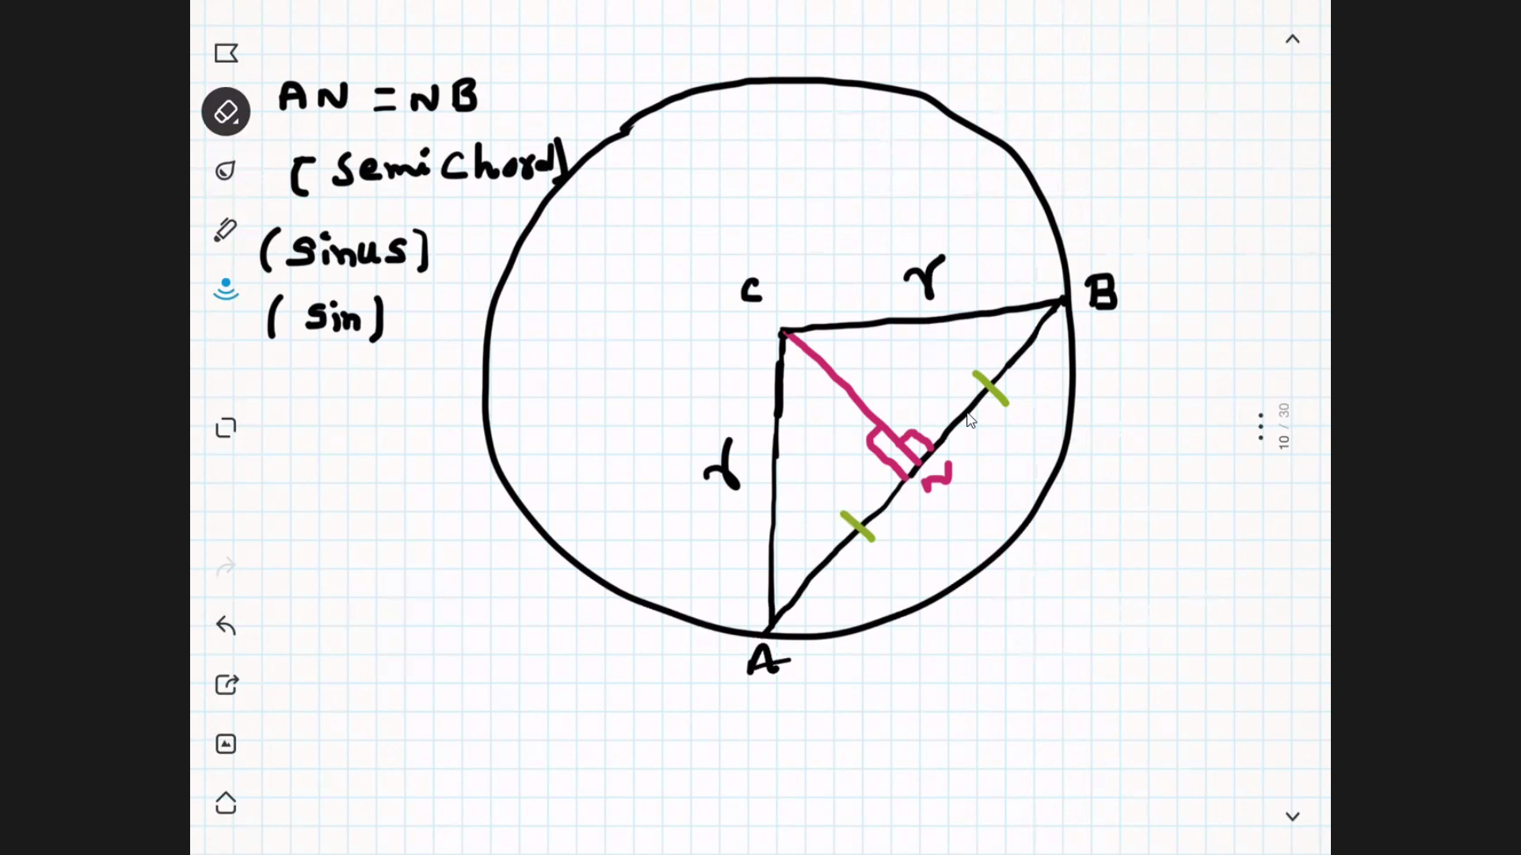

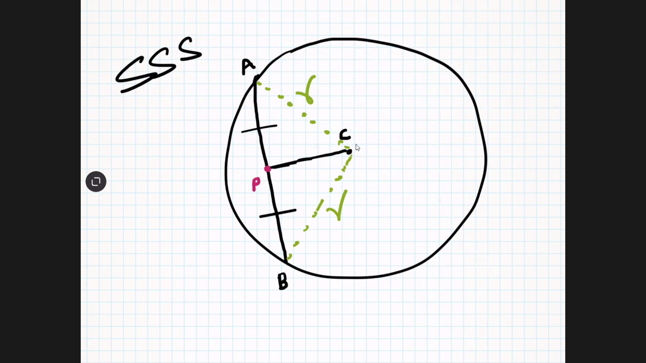

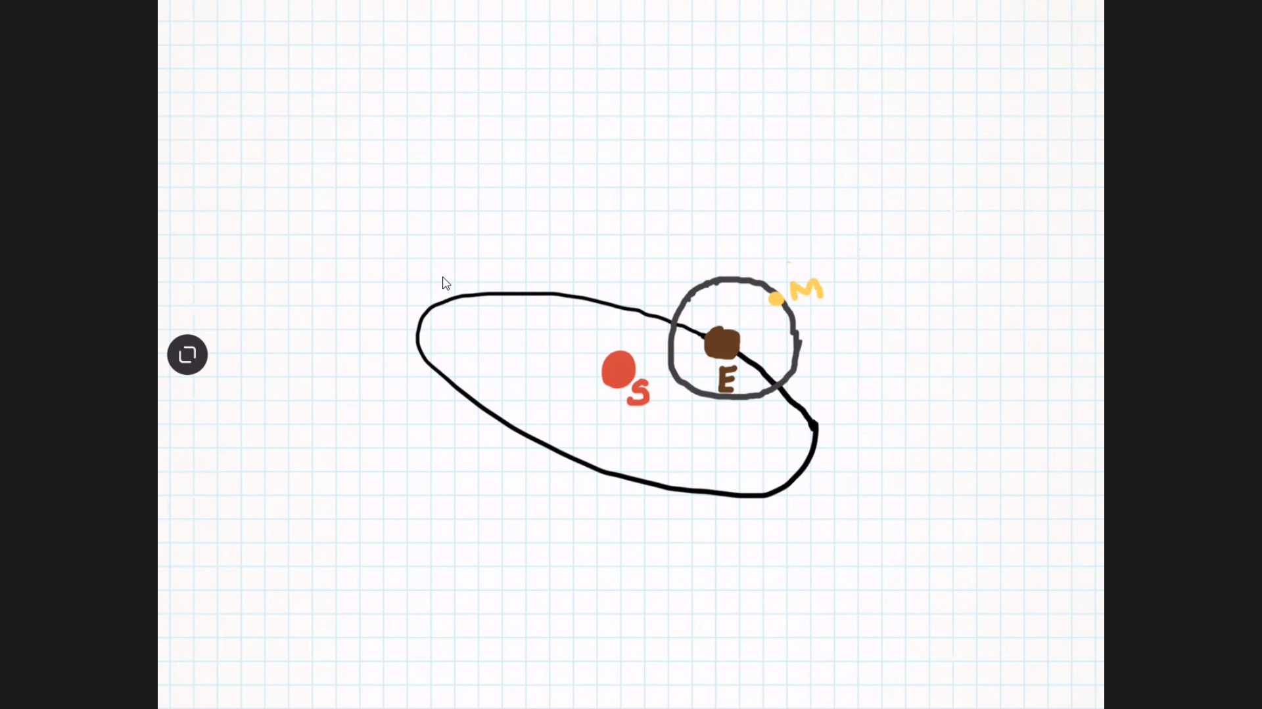

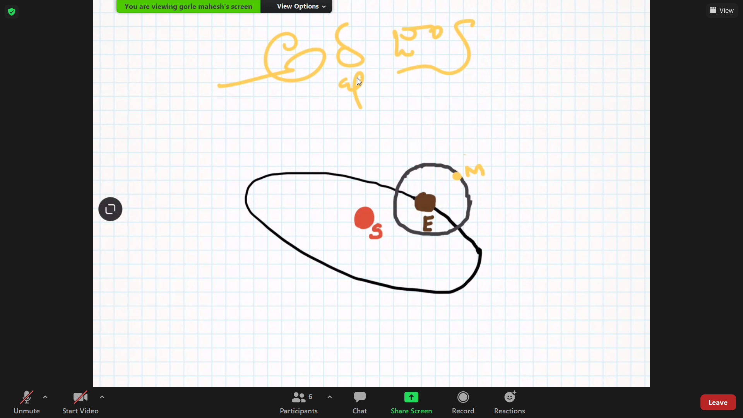

Sin is called artha jhya in Sanskrit. In English, semi chord. To study the impact of moon on earth, sin theta is thought to be used by Aryabhatta by using unit circle.

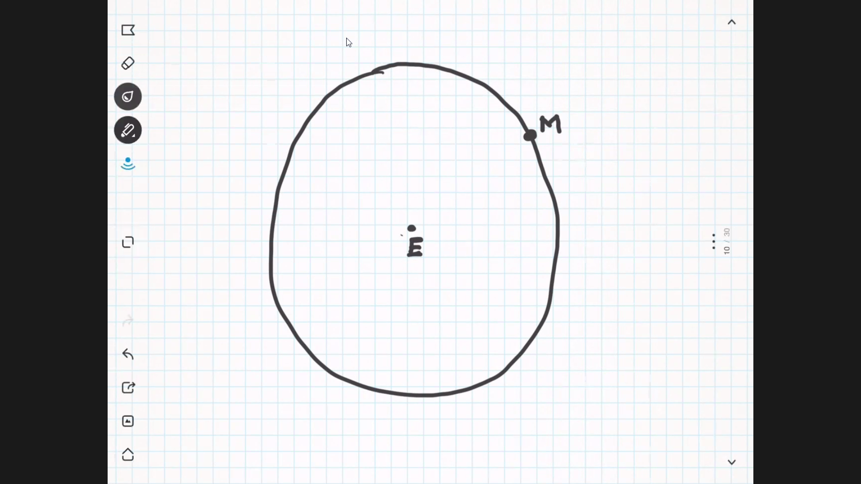

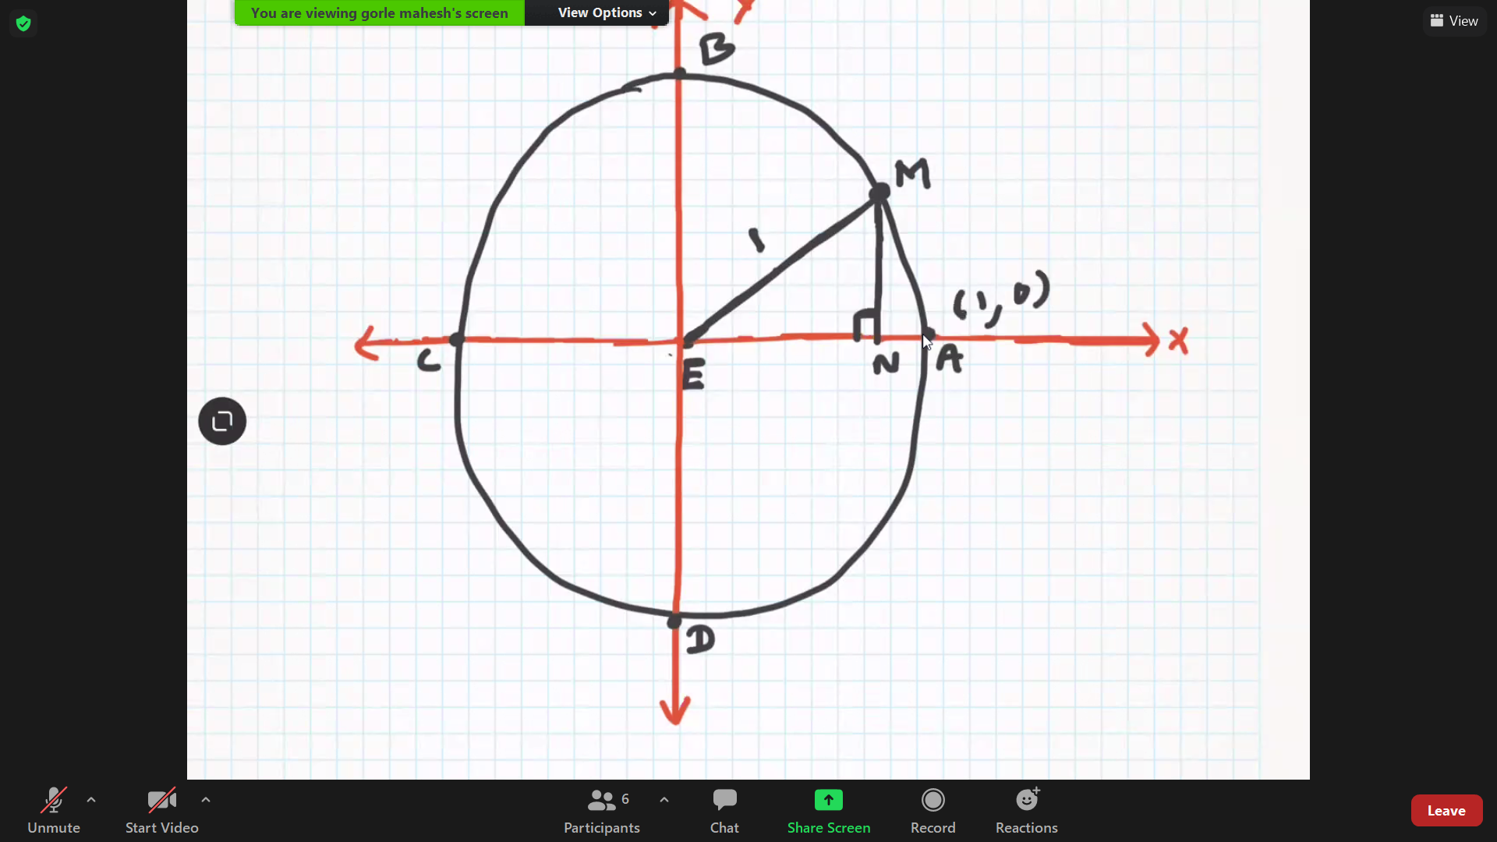

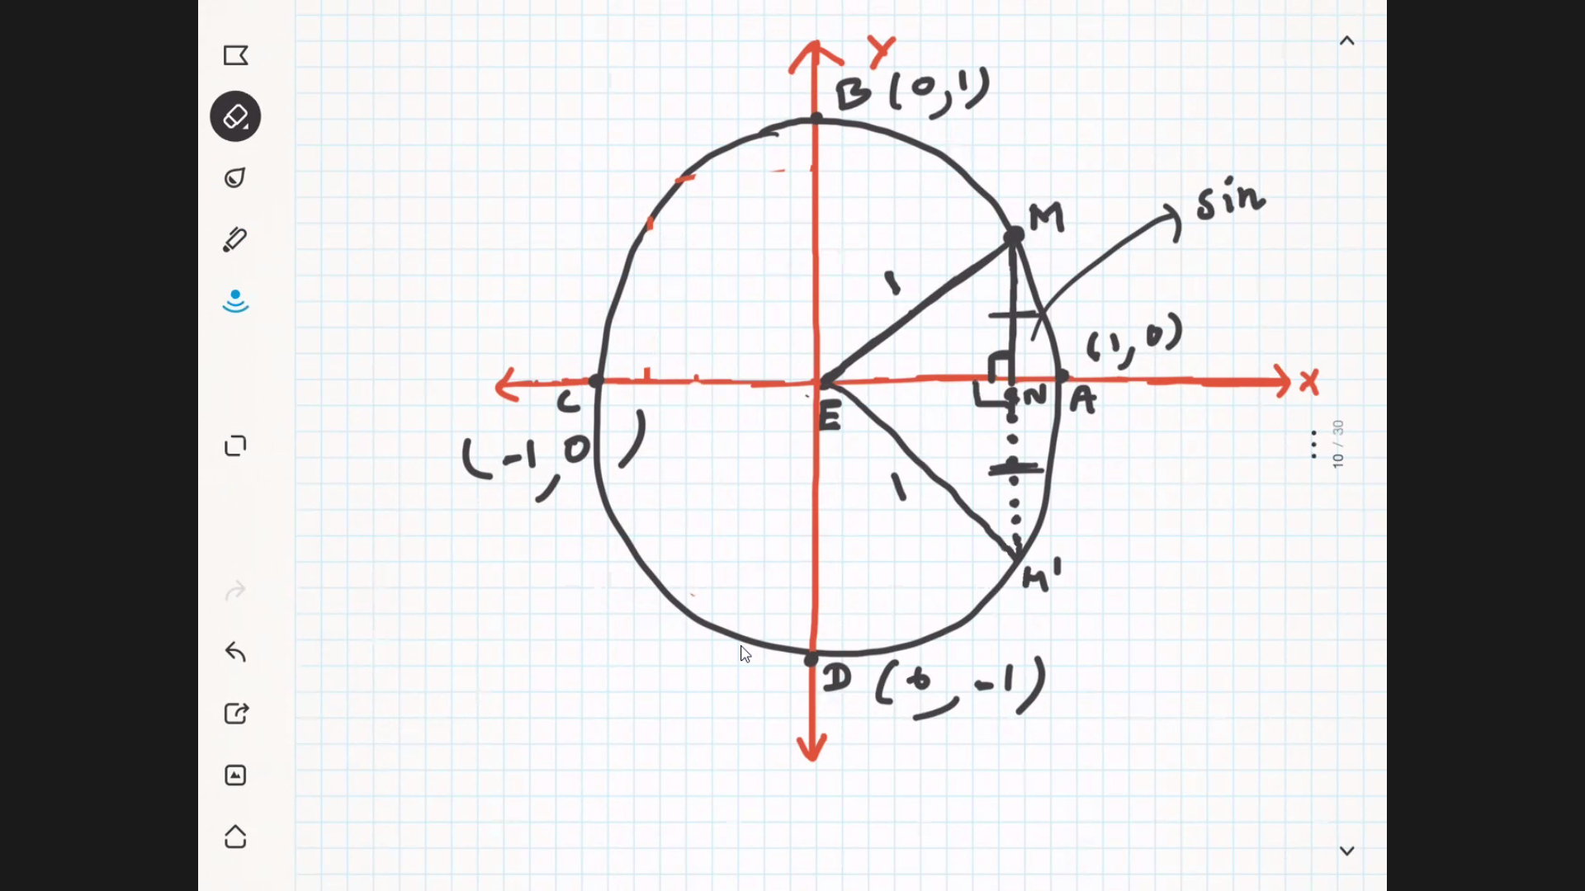

Sin is called vertical semi chord.

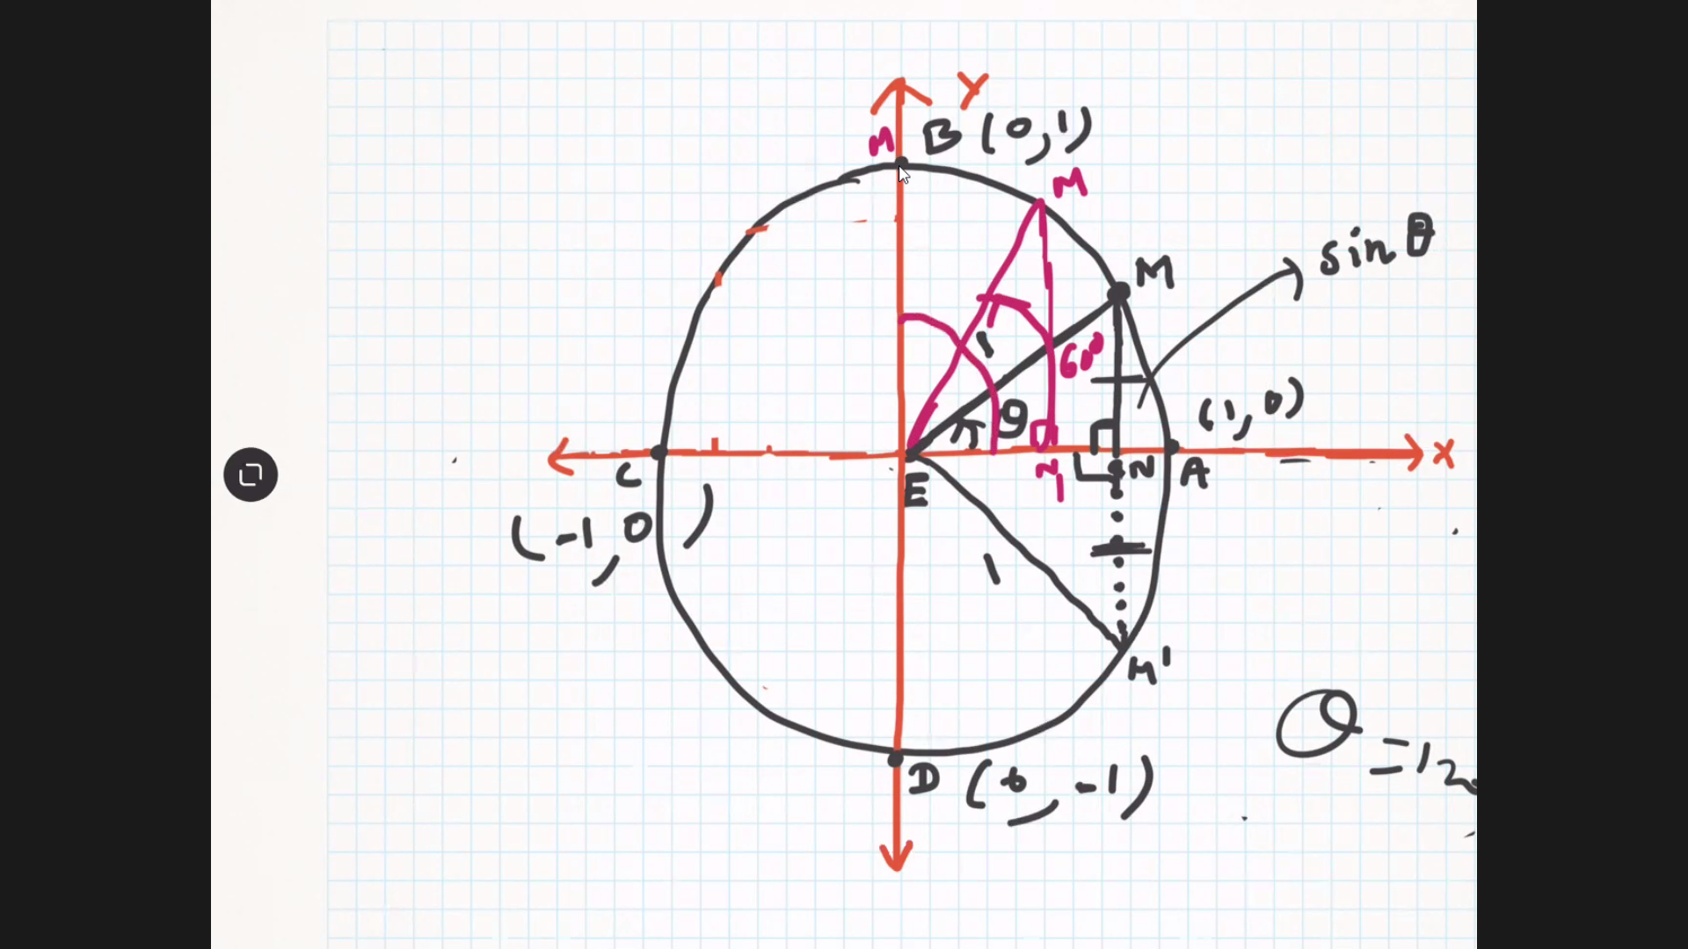

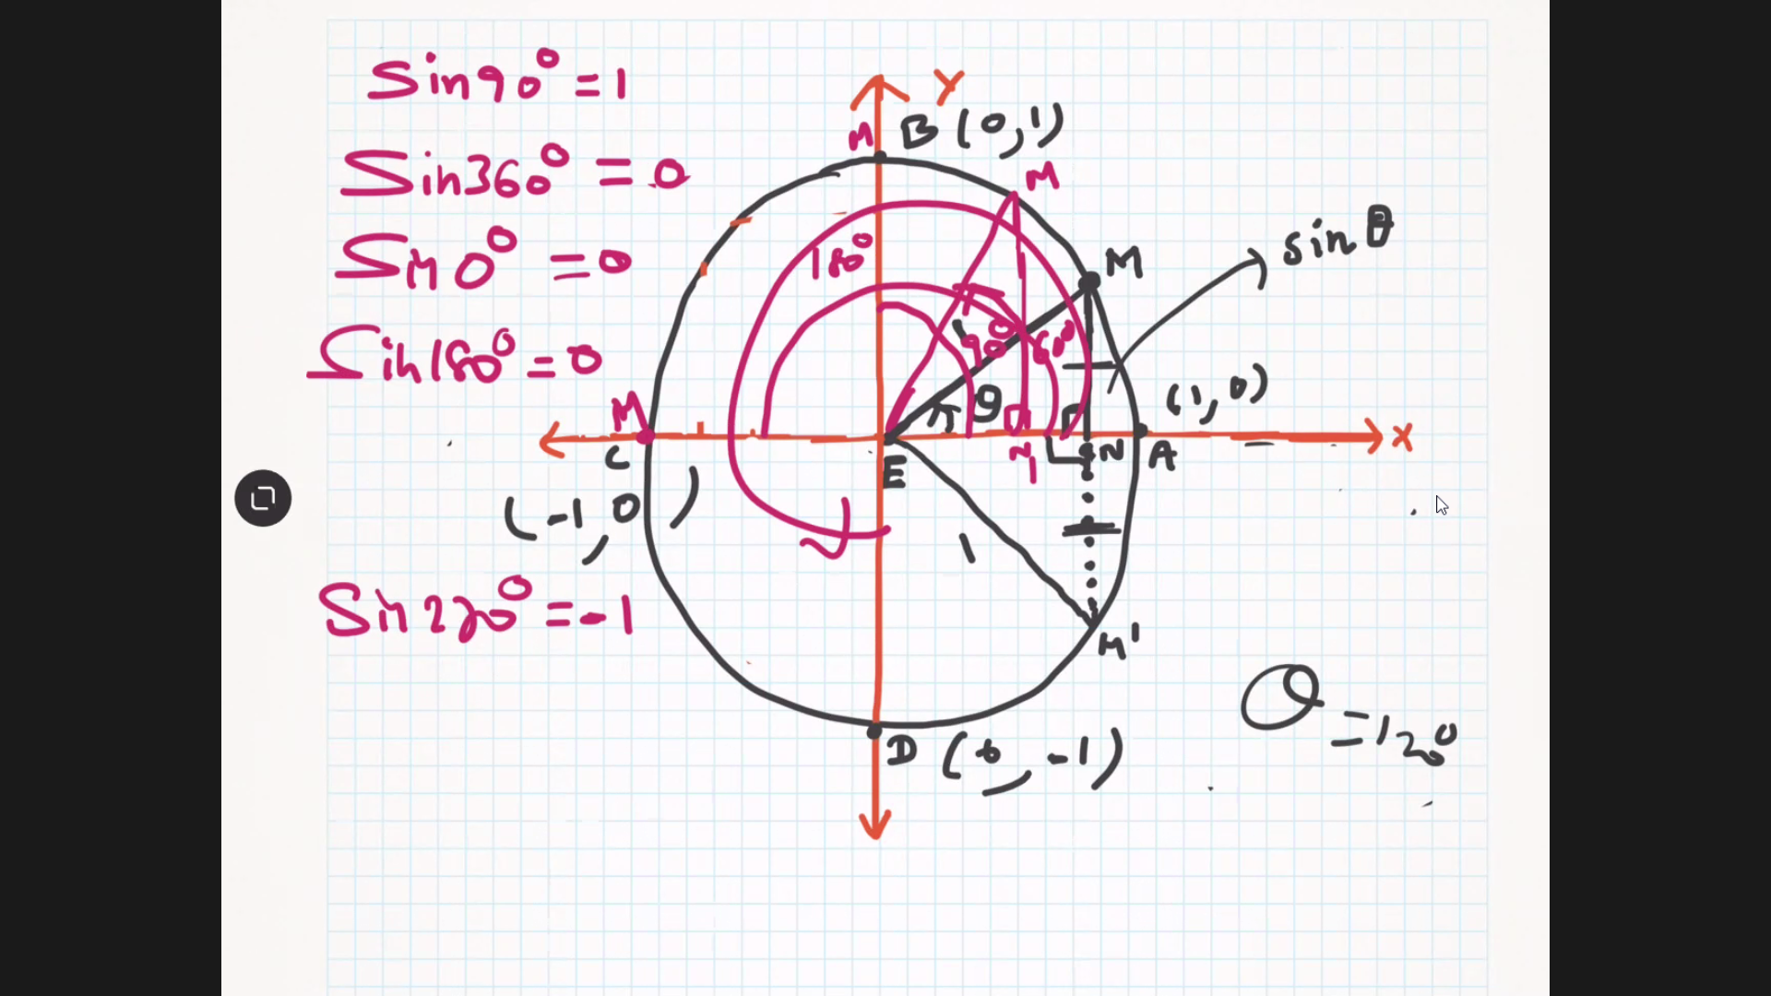

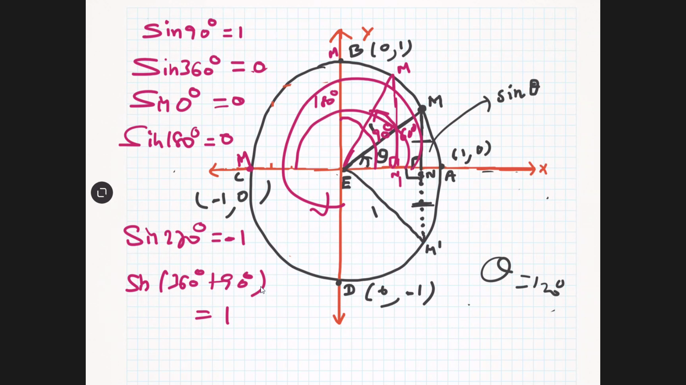

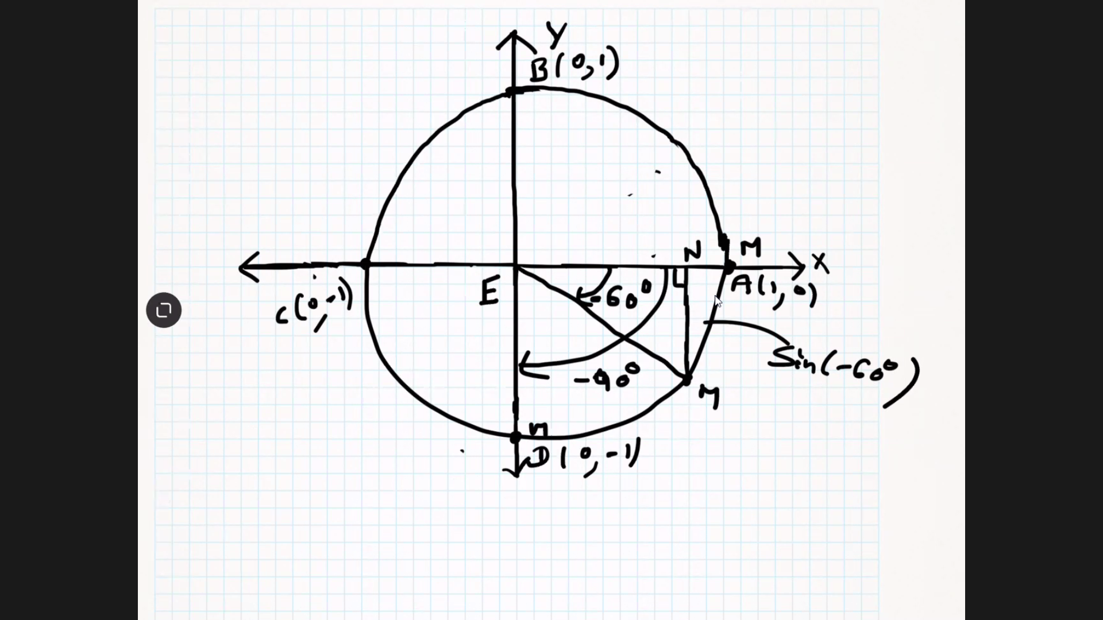

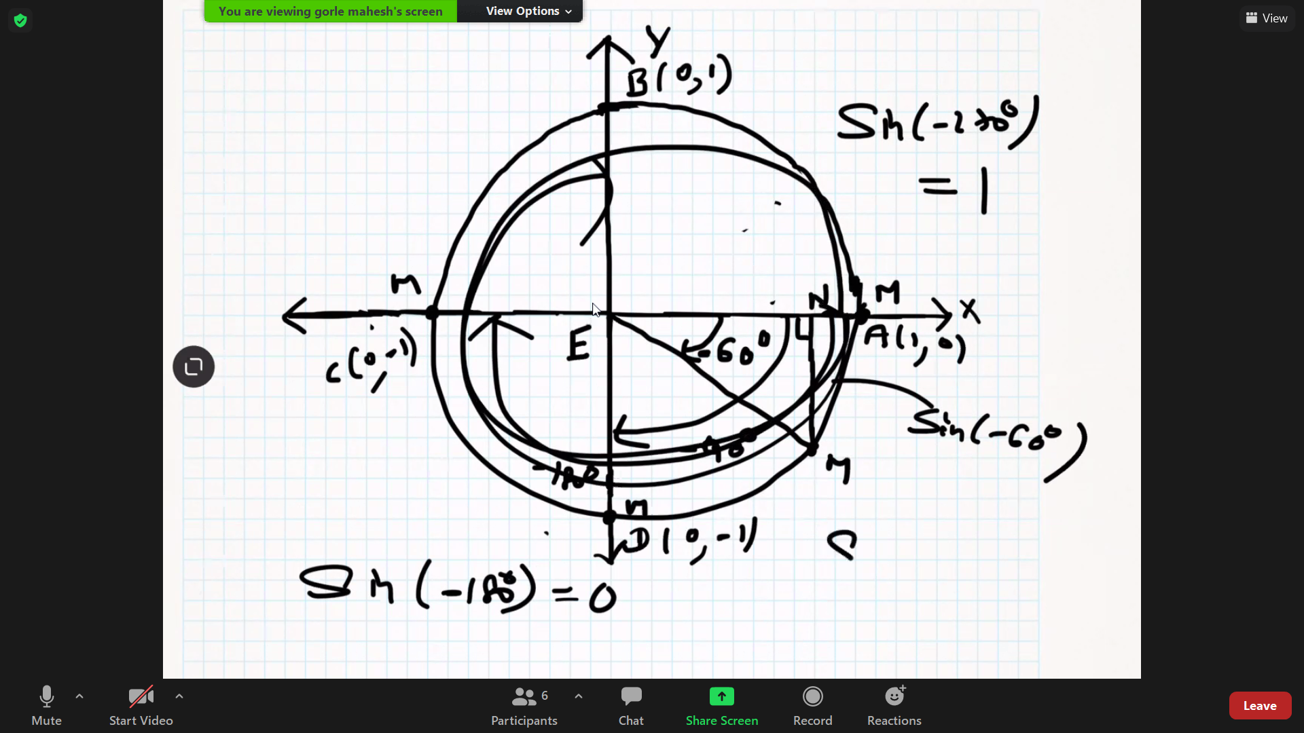

Sin is vertical semi chord in unit circle. [important Keywords for Sin theta:- Unit Circle, similar right angle triangle, Vertical semi chord]

Cos is horizontal semi chord in unit circle.

The side which is opposite to largest angle is largest side in a triangle.

Similar triangle formula is discovered by Thales mathematician.